Chapter- 3

RAIN ON THE ROOF

By- Coates Kinney

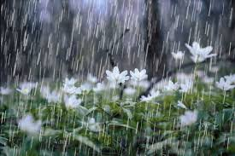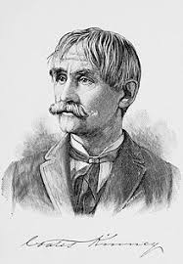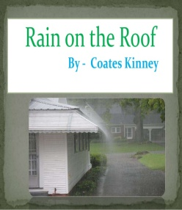

INTRODUCTION
When the sky is covered with dark clouds and it starts raining, everybody feels thrilled. One wishes to lie in a cosy bed and thousands of fancies rush through his mind. It is most joyful to enjoy listening to the music of the pattering sound of the rain-drops on the shingles of the roof. The poet expresses his love for nature and its beauty.This lyrical poem “Rain on the Roof” by Coates Kinney presents the memories aroused in the poet’s mind by the showers falling on the tin roof. Through a number of metaphors, the poet shows that the drops of rain falling on the shingles of the roof sends a train of thoughts running in his mind. He is reminded of the way his mother used to bid him and his siblings a good night and put them to sleep. The poet connects his present with his past through the memories revived by the rain.

THEME
The theme of the poem is the healing power of rain. The musical sound of raindrops falling on the rooftop at night has the ability to revive sweet memories and rouse fancies in an otherwise busy mind. The rain thus soothes and comforts an overworked mind by taking it back to its lovely past. Some of our best memories in life are associated with rain.

Title
The very title, with a repetition of the sounds ‘r’ and ‘n’ and the long vowels ‘ai’ and ‘oo’ imitates the rhythmic pitter-patter of rain on a tin roof. Article ‘the’ before the word ‘roof’ makes it a specific roof – the roof of the poet’s house. Thus, the title is very apt as it is suggestive of the childhood memories the poet has of rain. The rain has magic like an effect on him every time it falls on his room and lying lazily in his room, he listens to the sheer music of the rain. It triggers ‘a thousand dreamy fancies’ in his mind and thousands of memories come alive. In particular, the memory of the poet’s mother putting her children to sleep at night is indelible in his mind. Every time it rains, the poet relives the golden moments of his childhood. Thus, the title of the poem can be termed very appropriate
MESSAGE
The poem conveys the message that rain has therapeutic and healing powers and forms lasting memories in the human mind of the sights, sound, fragrances and our experience associated with it, especially those involving our loved ones. Rain refreshes and rejuvenate us and forces us to recollect and relive our past memories.
LITERARY DEVICES
Alliteration

Alliteration is the repetition of sounds in a sequence of words. It lends a lyrical or musical element to a poem.
Examples:
- Overall the starry spheres
(Here ‘s’ and ‘r’ sounds are repeatedly used)
- What a bliss to press the pillow
(In this line ‘s’ and ‘p’ sounds are used repeatedly)
- Into busy being start
(Here the poet uses ‘b’ sound repeatedly)
- Now in memory conies my mother
(Here we find alliteration, as ‘m’ sound, is repeated)

- 0! I feel her fond look on me
(Here ‘f sound is repeatedly used)
Personification
Personification is a literary device in which human traits are attributed to inanimate things or birds, beasts and trees such that they seem to be living beings.
Examples

Here the poet personifies darkness who is presented to be in a melancholy mood and sheds tears in the form of raindrops.
- And a thousand recollections
Weave their air-threads into woof
Recollections are personified here as they are shown to be weaving cloth with threads of air.
Transferred Epithet
Transferred Epithet is a poetic device in which an adjective is used not with the noun which it qualifies but with some other noun.
Examples:
- melancholy darkness
Here it is not the darkness that is sad but some human beings who are sad in the darkness.
- dreamy fancies
Here fancies are not lost in dreams, but it is the human beings who dream.
Onomatopoeia
Onomatopoeia (sometimes called echoism) is a figure of speech in which words imitate the sound or sounds they describe. In other words, the sound an onomatopoeic word produces is the meaning it intends to convey. ‘Bang’, ‘pop’, ‘hiss’ etc are some onomatopoeic words.
Examples:
- patter
imitates the sound the raindrops make as they land on the surface of the roof tiles.
- tinkle
imitates the gentle and clear musical sound that a droplet makes.

